**Web Design**

yipeng chen

# Summary

I want to design a website that shows some famous people & interest area social media update. Twitter, ins, youtube, facebook, news app… There are many ways to watch if we want to follow one’s social media update. But sometimes it’s time-cost since you need to open different apps and other information not related what you are interested in. So I want to gather all things together into one website so that one can just view one website to get all.

In this assignment, I will use NBA field as an example.

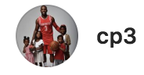

source: Instagram  
time：xxx

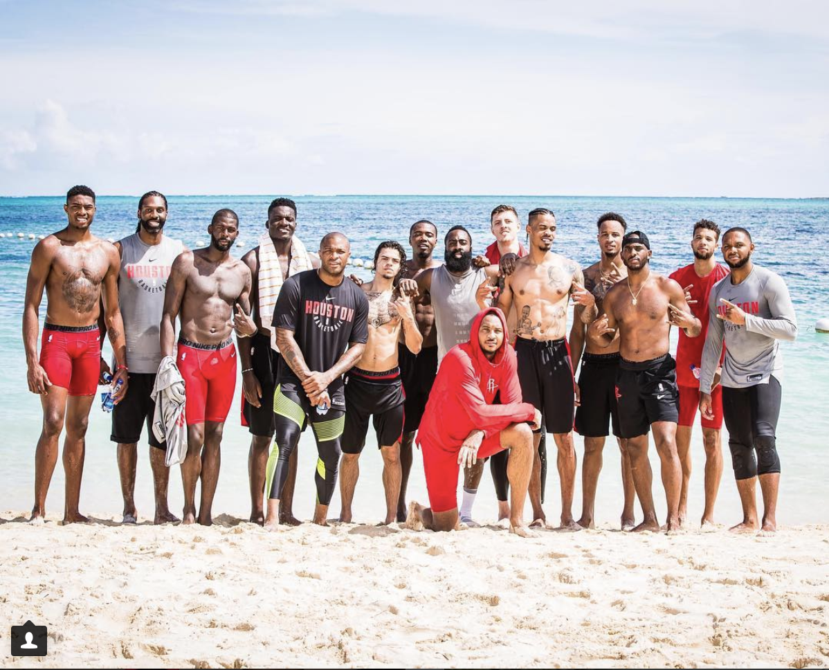

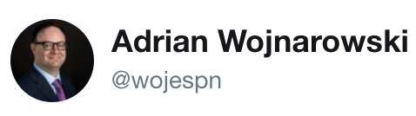

source:twitter  
time:xxx

On Naismith Basketball Hall of Fame Weekend, several of us wrote on those who aren't in Springfield but ought to be. I made the case (again) for the most glaring omission as a contributor to the game: John Paul Vincent (Sonny) Vaccaro.

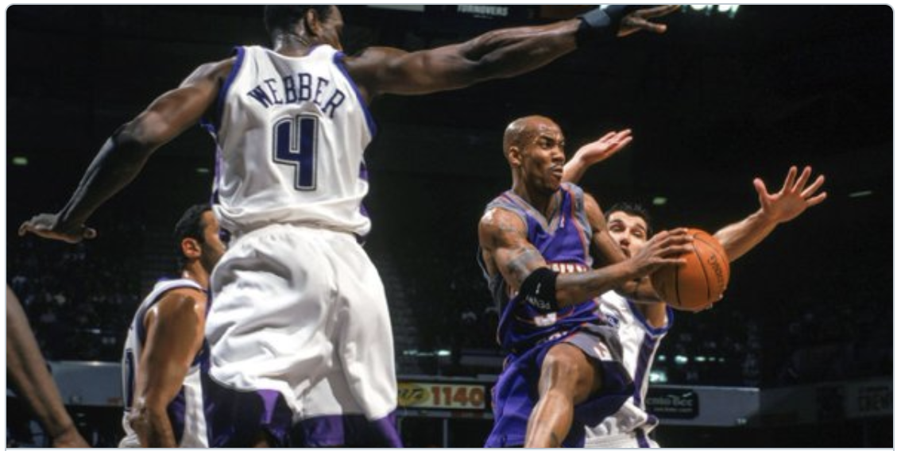



source: reddit  
time:xxx

The Rockets take a team photo at the beach

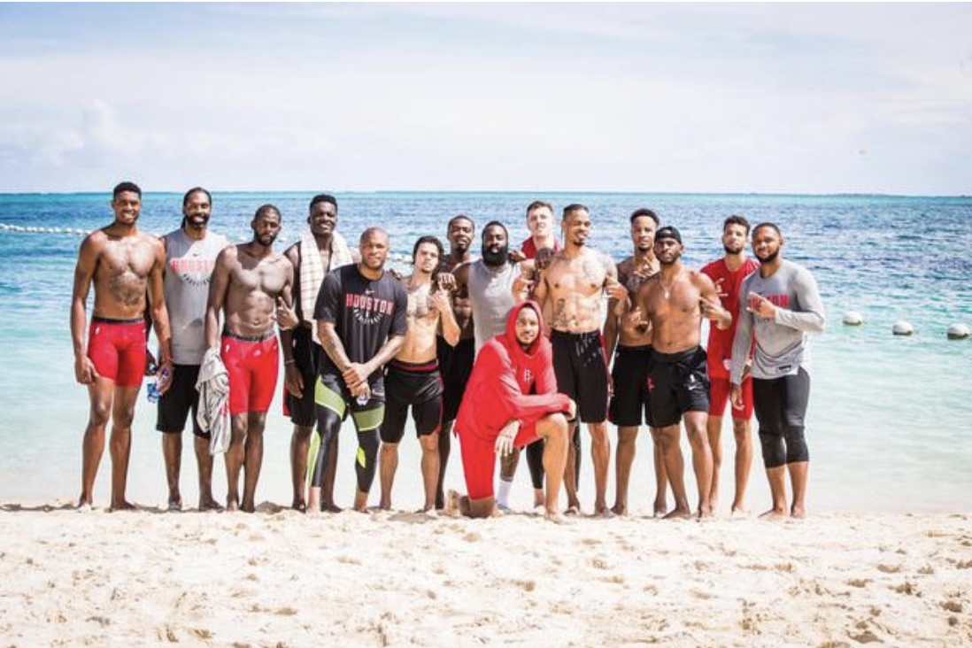

Or if you want to only see one guy. Then just for the content of one person.

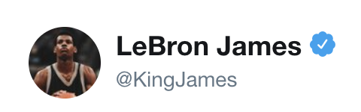

source: twitter  
time:xxx

There’s only one thing I can say negative about Kamikaze and that is “Kamikaze” and “Fall” on the track list is misplaced! 



source: Instagram  
time:xxx

